Project Report on Student Connect Portal Website (CS 6314.501)

Group Members:

Koulick Sankar Paul (ksp160330) Nirmallya Kundu (nxk161830)

Abhishek Datta (axd151630) Gunjan Tomer (gxt160930)

# Website designed - SCONNECT.XYZ

SConnect - Student Connect, is a new initiative by the 4 students of University of Texas at Dallas along with the advisor Dr. Timothy McMahan, to present to the students at any level with an educational social media which has lot of capabilities to meet the present and future requirements.

It is a socio-academic web portal for students and faculties from different universities to connect, interact and track their regular academic activities. It has aspects like profile, feed, text/photo/video upload and like/dislike/ comment on posts similar to a social media, as well as functionalities like add new class, create coursework, give attendance and one-on-one messaging like any university academic portal.

**Assumptions considered while designing the application-**

1. The user should be having his university email id to login. In case, he is logging in for first-time he should pass through the verify login page where an OTP will be received through his email

2. While sending one-on-one message to any person, the user should be aware of the other person’s email address

3. It is assumed that the students have already enrolled for the course for the session, based on which the faculty provides the class roster (email-ids for eligible students to join) while creating the course in SConnect portal

**Project-level Implementation of core functionalities**:

Code-level implementation of the website design and implementation was done using the LAMP stack wherein front end included HTML, PHP, CSS, JQuery and backend has PHP with MySQL database structure.

**File-structure followed while developing the application**

Data folder has all the SQL-related activities defined

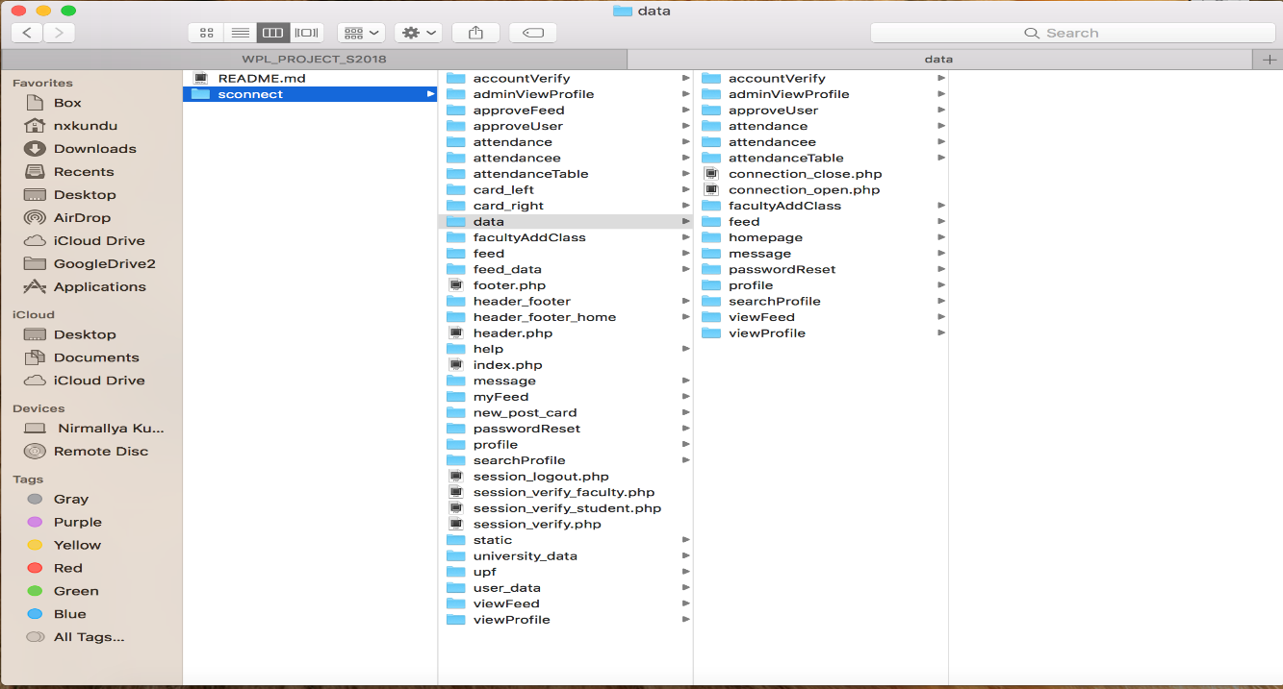

Static folder has all cs and javascript/jQuery modules defined separately for any functionality

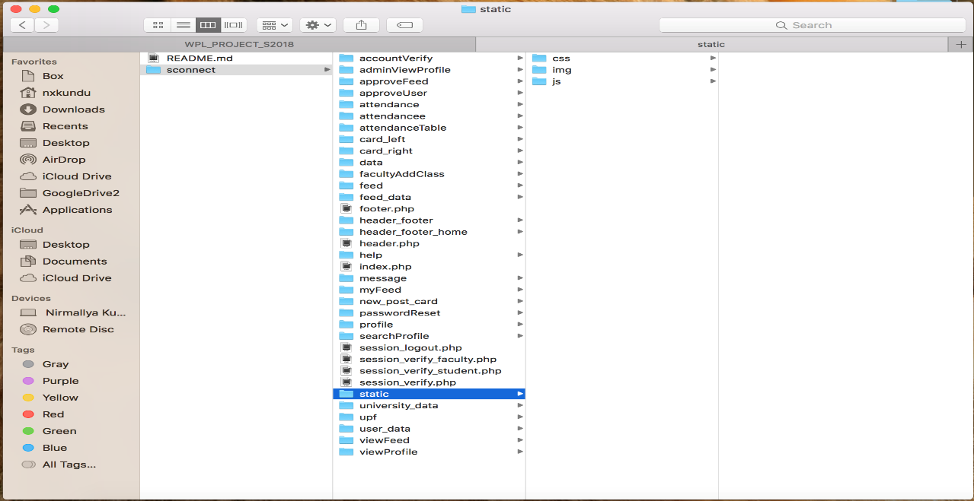

Please find below a brief overview on how the overall website functionality flows from the login page till help page:

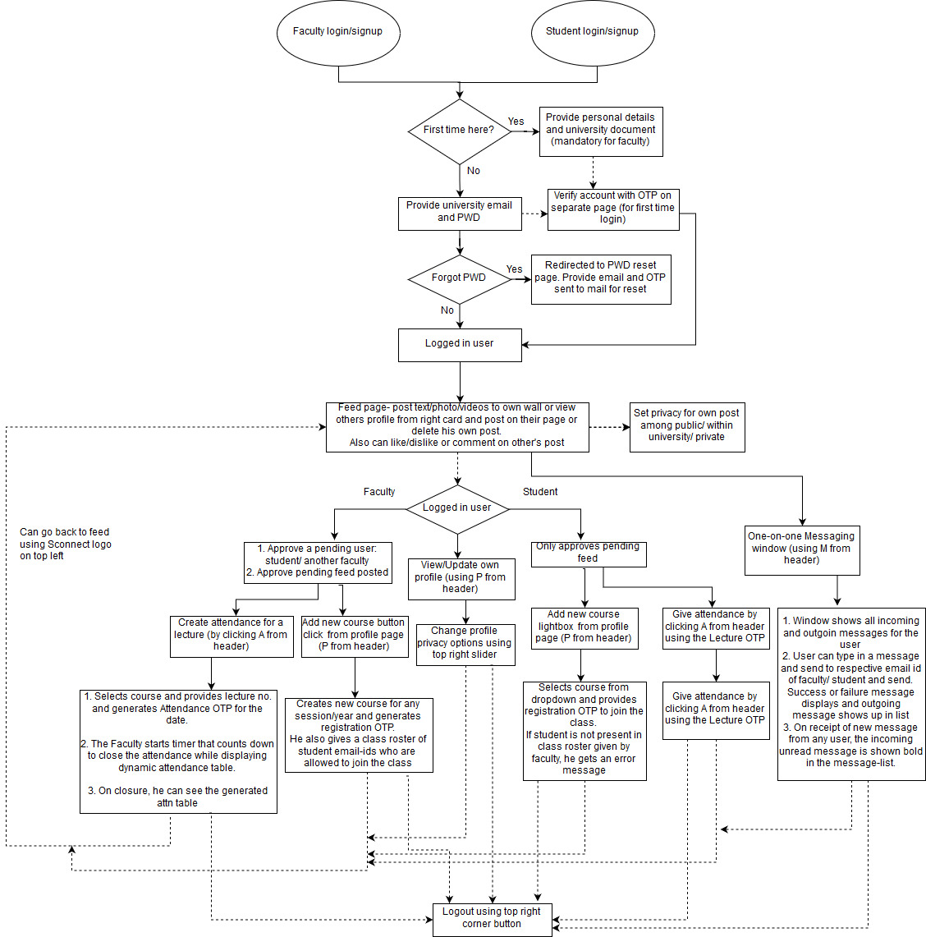

**Application functionalities**

Below screenshots shows the main functionalities of the website designed and implemented:

**Login page:**

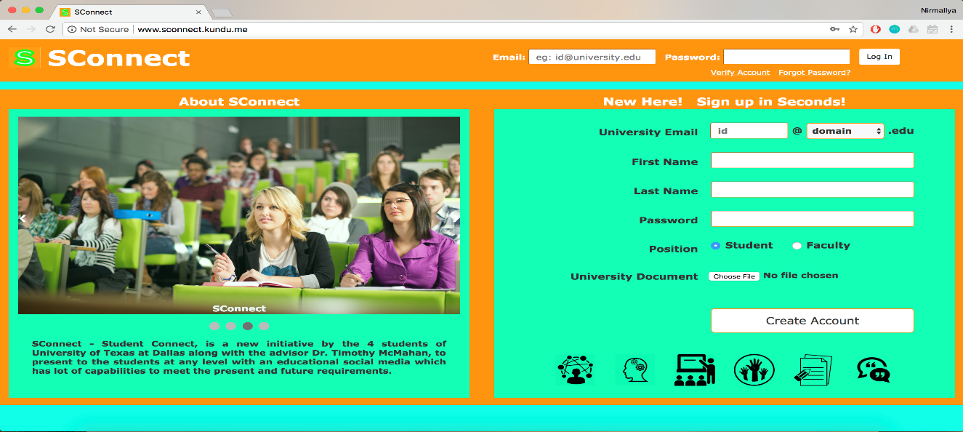

**Forgot Password page:**

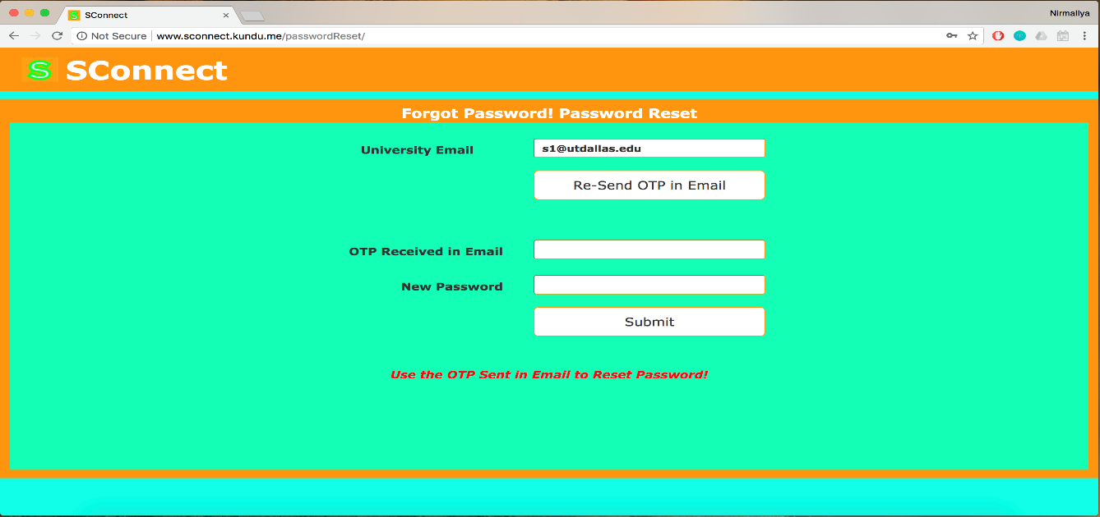

**Verify Account page:**

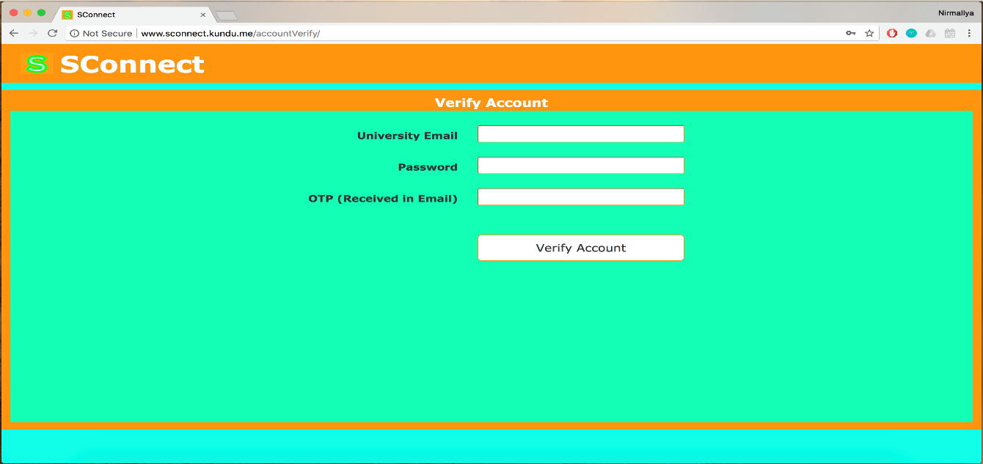

**My Feed page:**

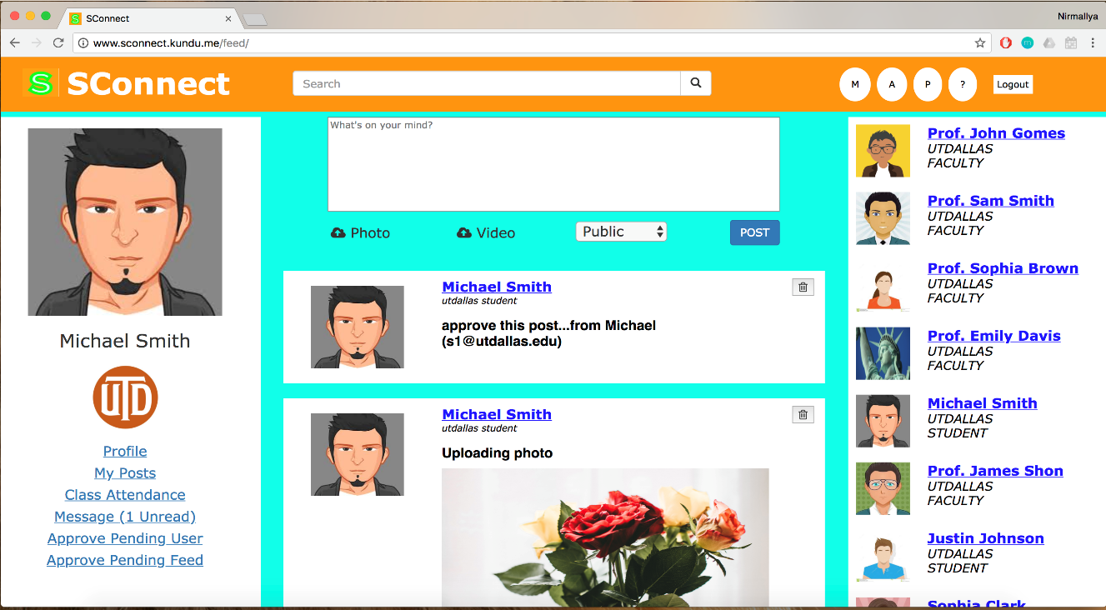

**Feed like/comment/post:**

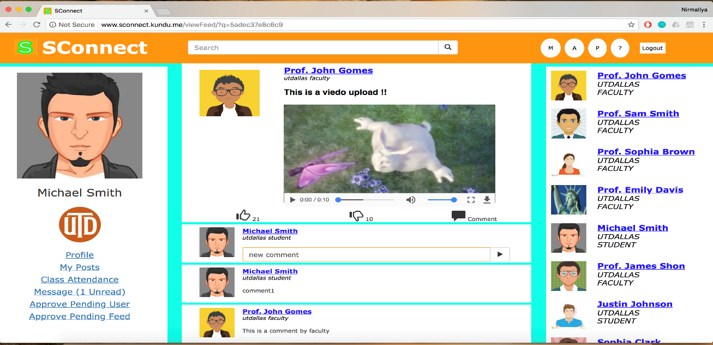

**Search User/Feed from search bar:**

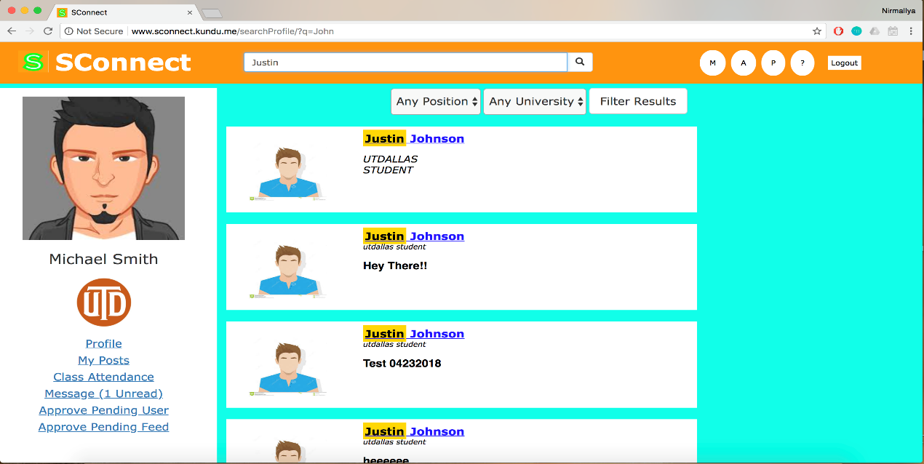

**Approve feed:**

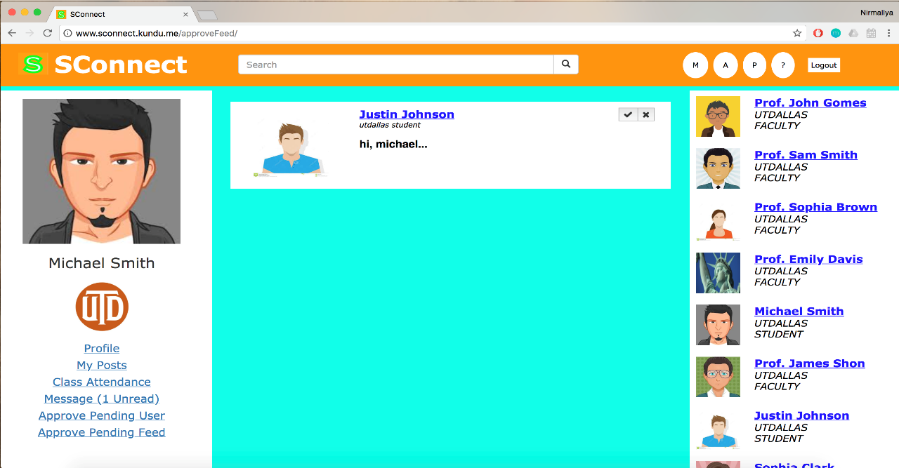

**Approve faculty funtionality:**

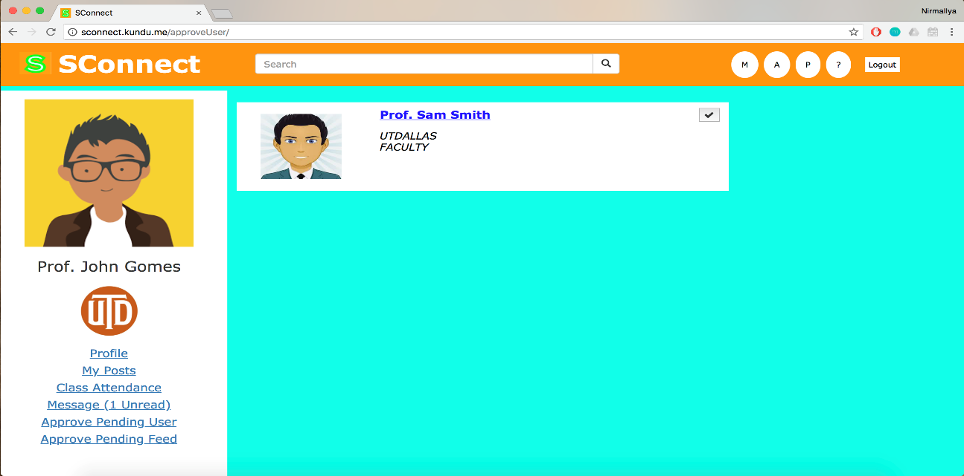

**Faculty Create attendance page:**

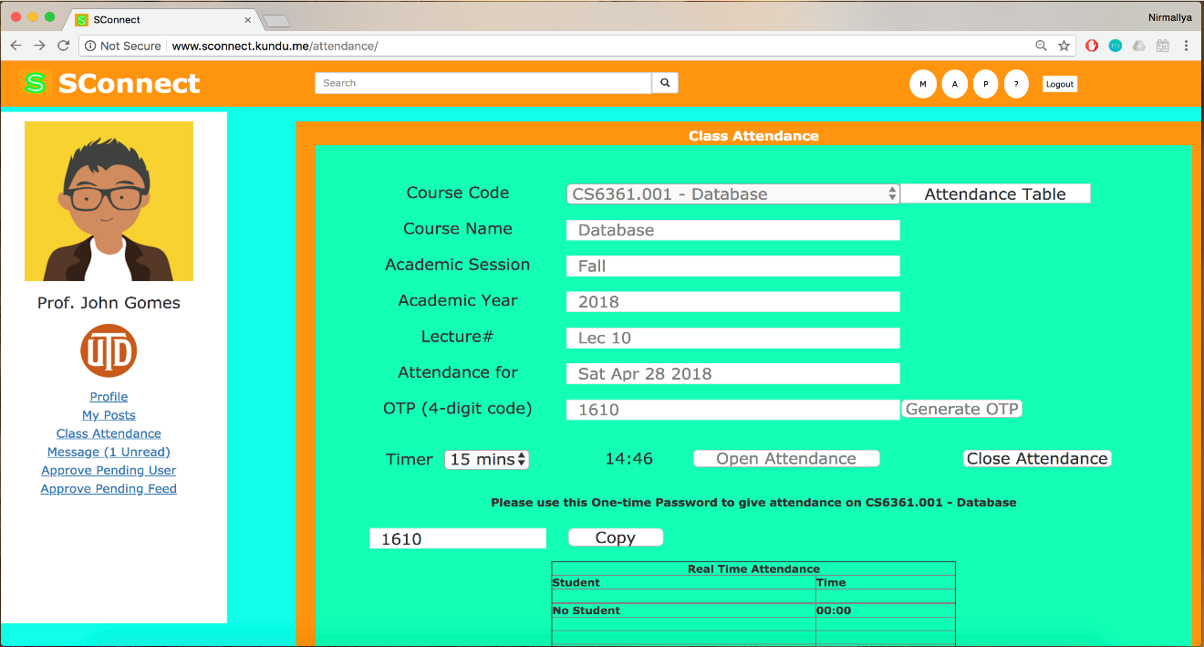

**Attendance table created:**

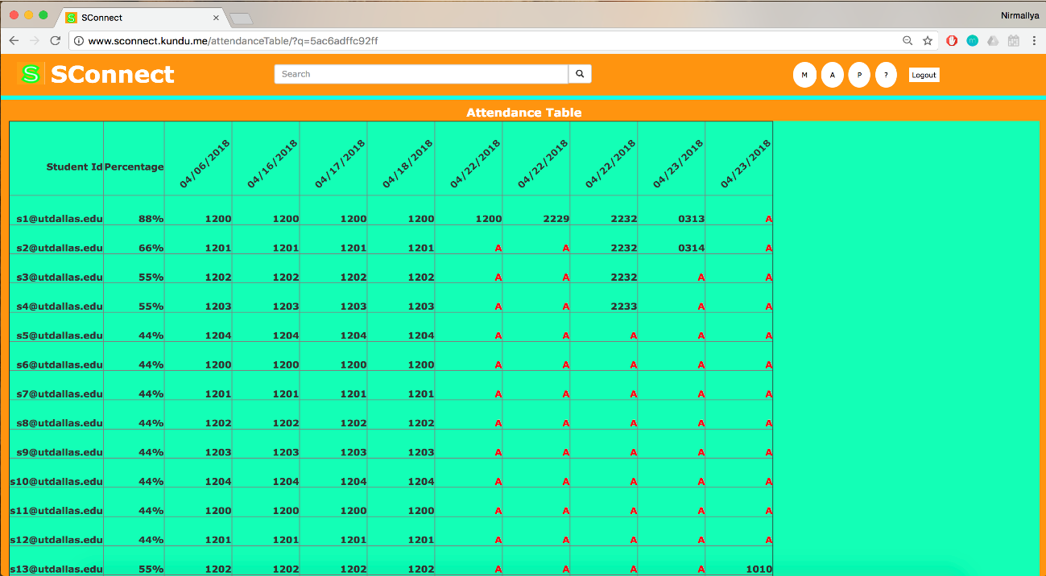

**Profile page self update:**

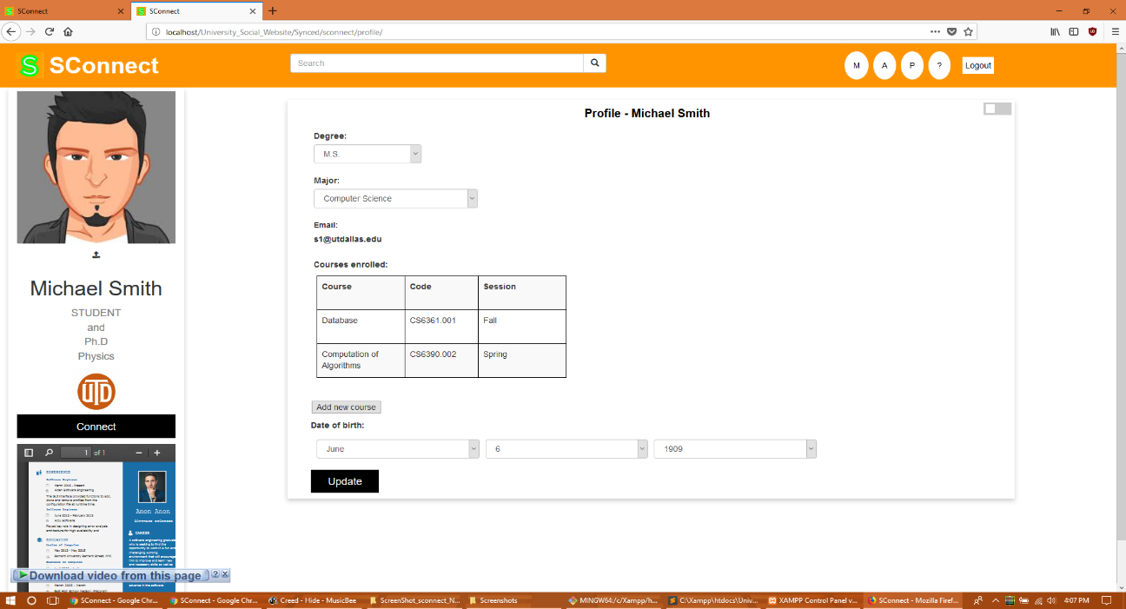

**Profile privacy settings:**

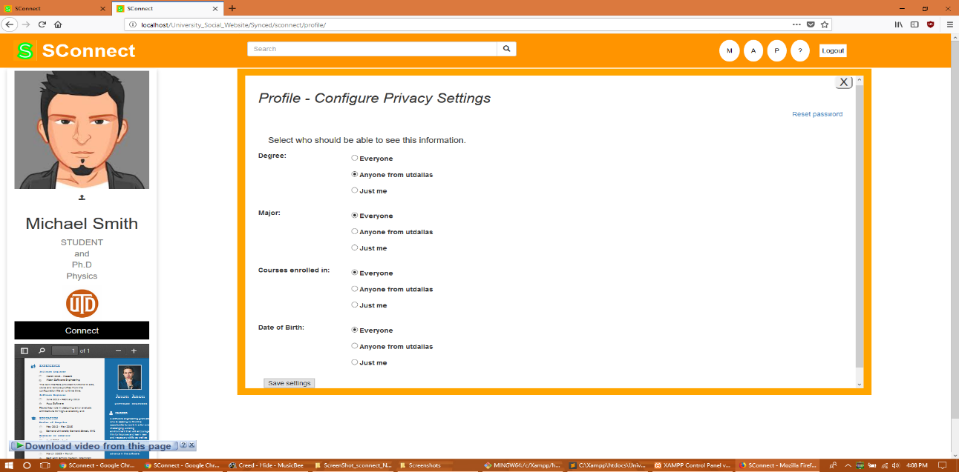

**View another user profile:**

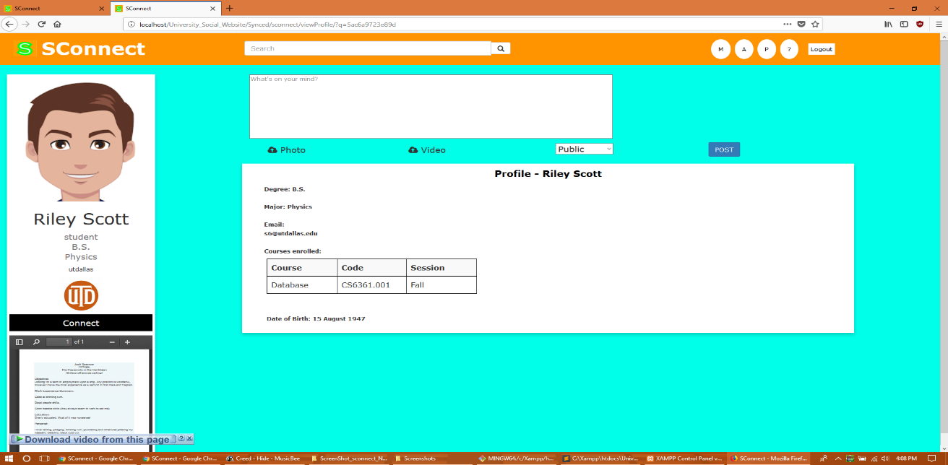

**Admin view profile for update/delete:**

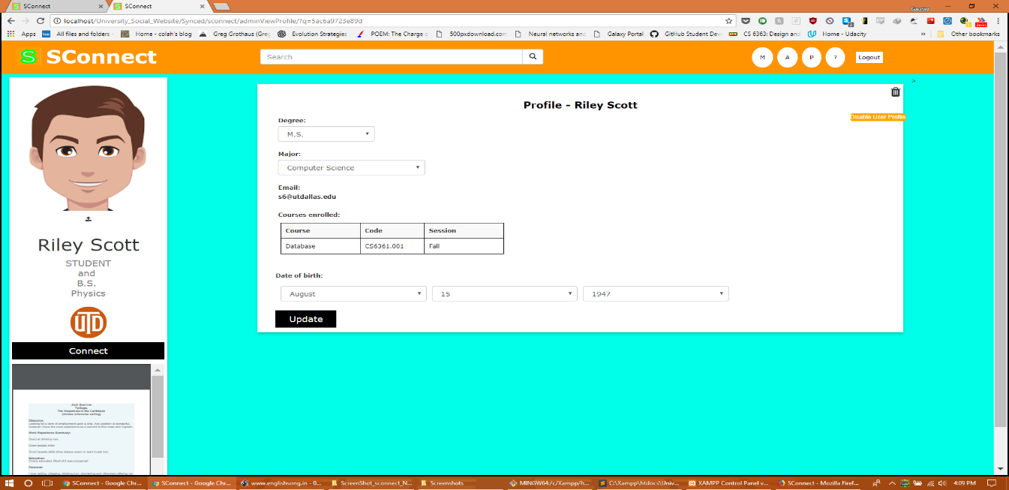

**Deleted User by admin:**

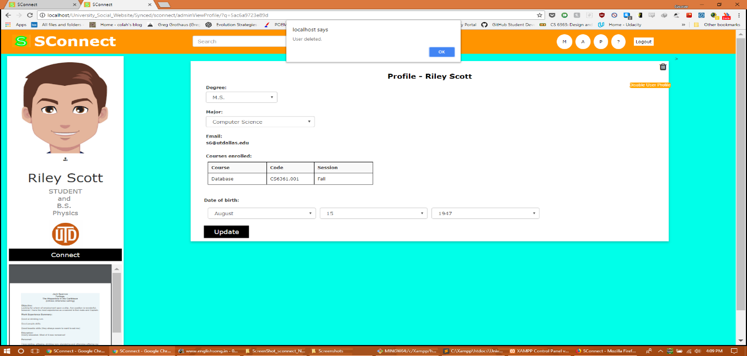

**Faculty Add new Course functionality**

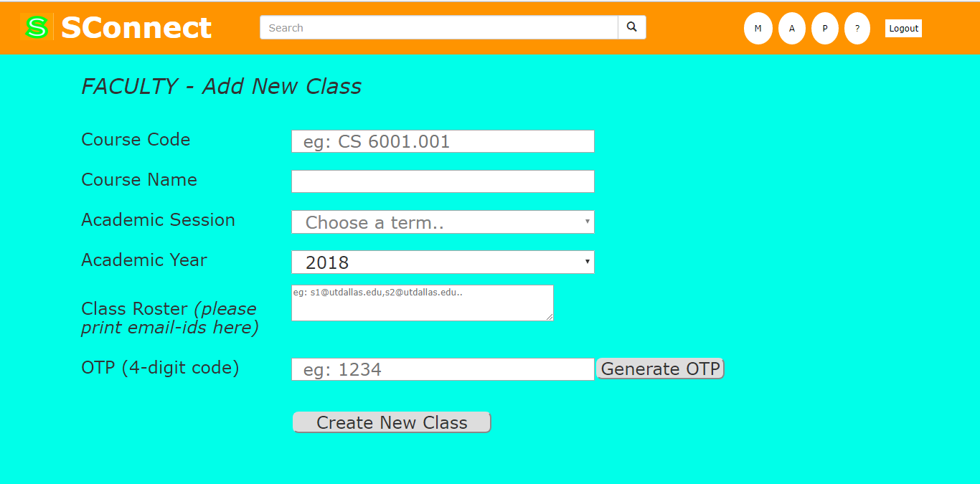

**Student Add new class based on OTP**

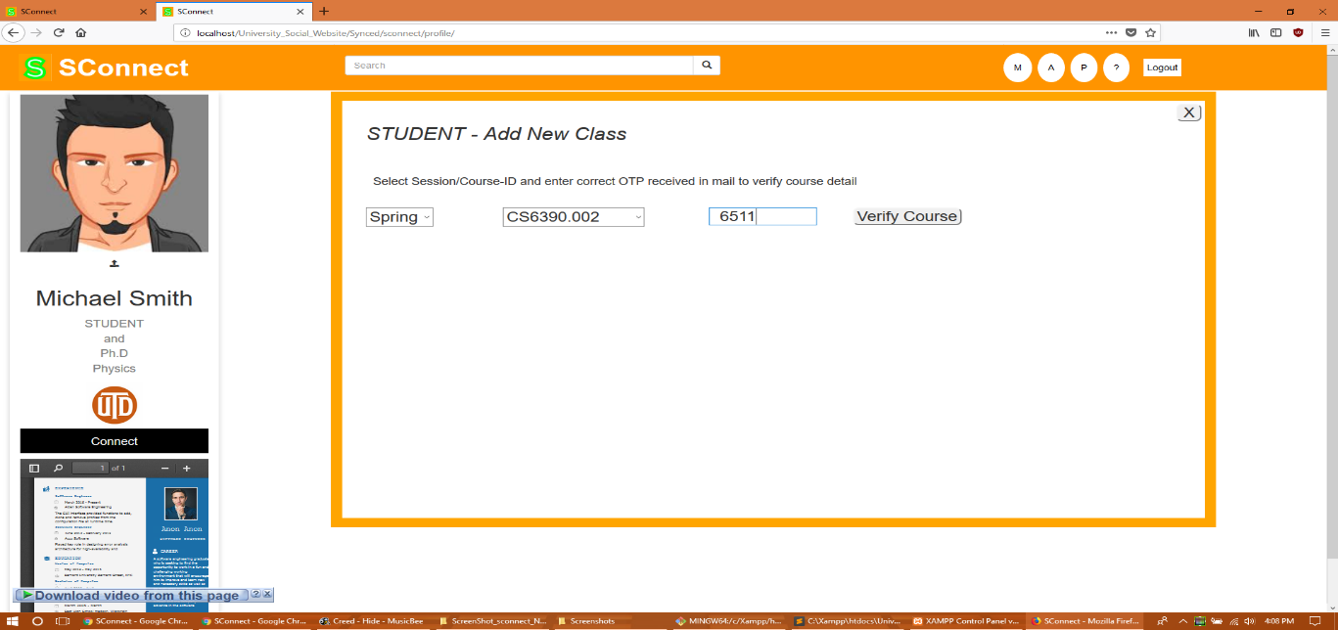

**Student Attendance based on Faculty attendance OTP created**

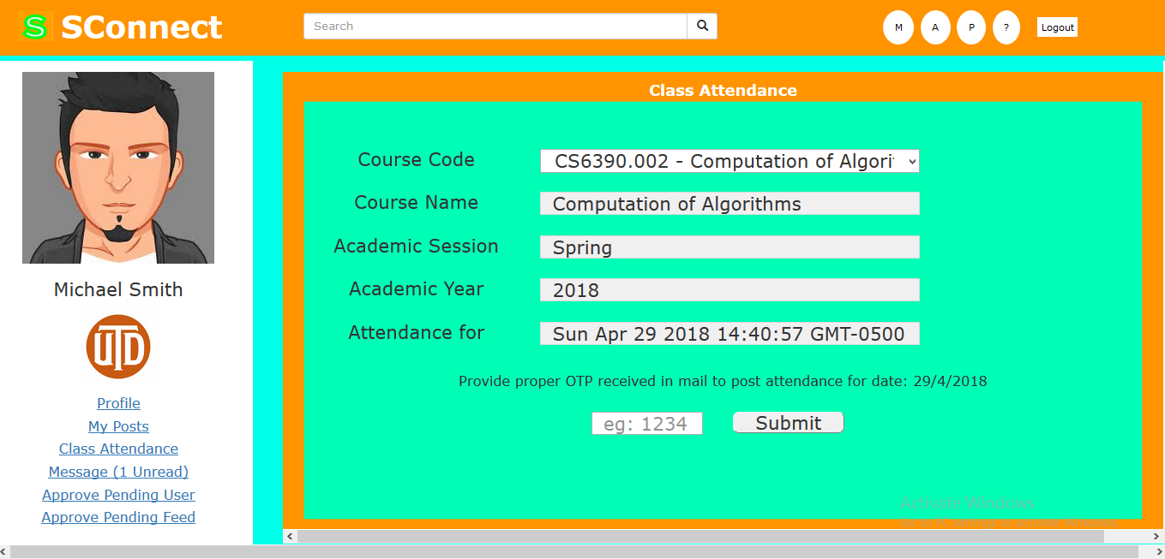

**Messaging UI functionality:**

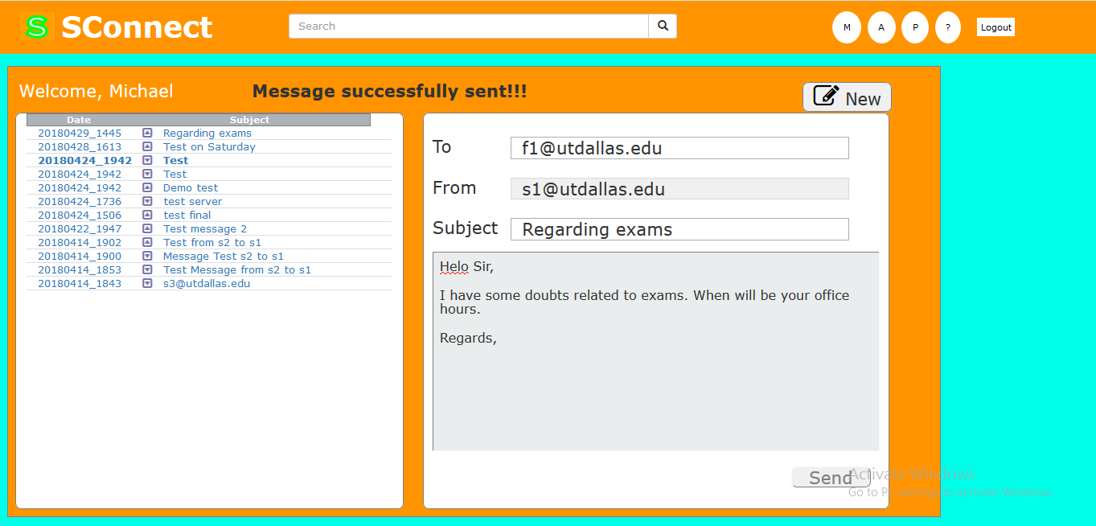

**Help and contacts page:**

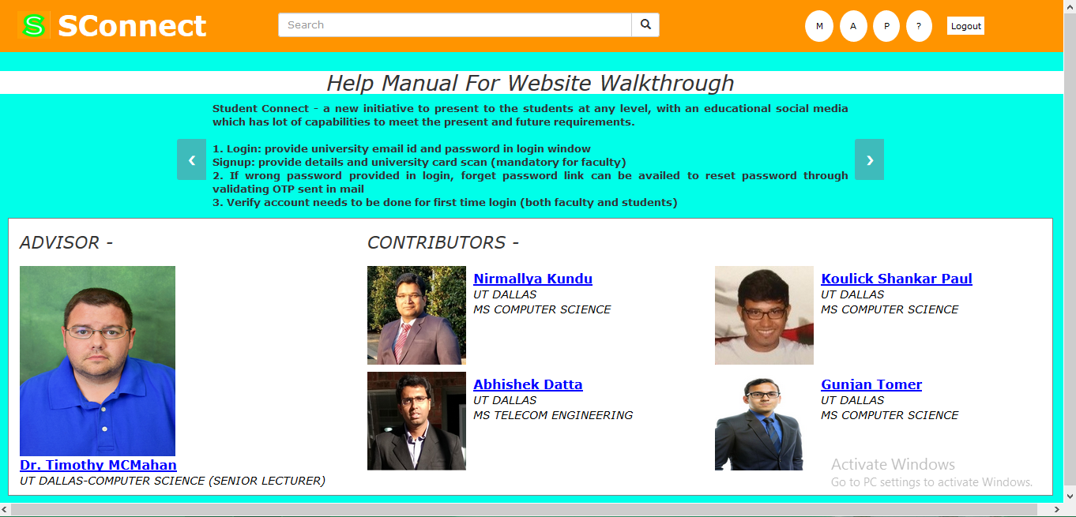

**Database and table structures used for the project design:**

MySQL database has been used for designing the project. We have a several connected tables for separate functionalities and foreign keys associating one with another. All the tables are normalised to 3rd normal form.

Please find the below screenshot for the MySQL table view from PhpMyAdmin tool, followed by the table definition statements provided

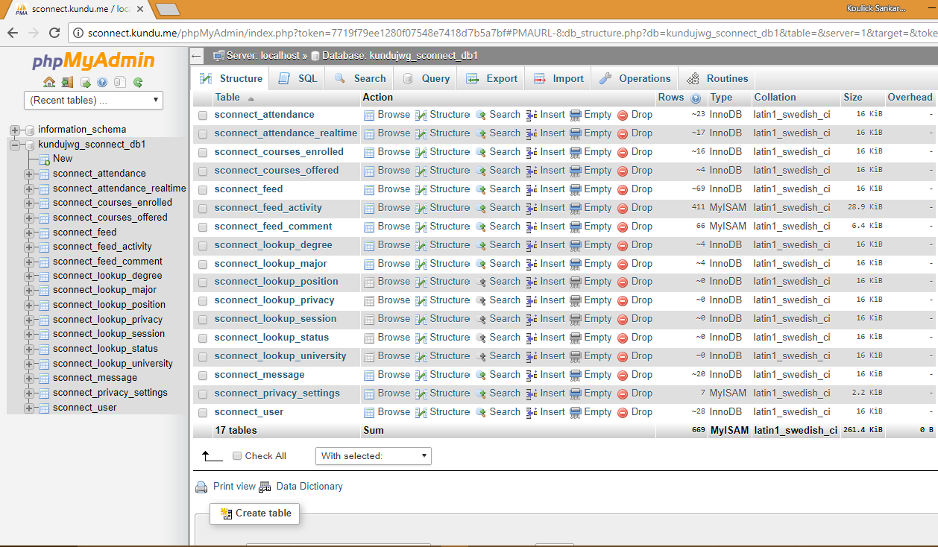

**Example values and structure for few tables created**

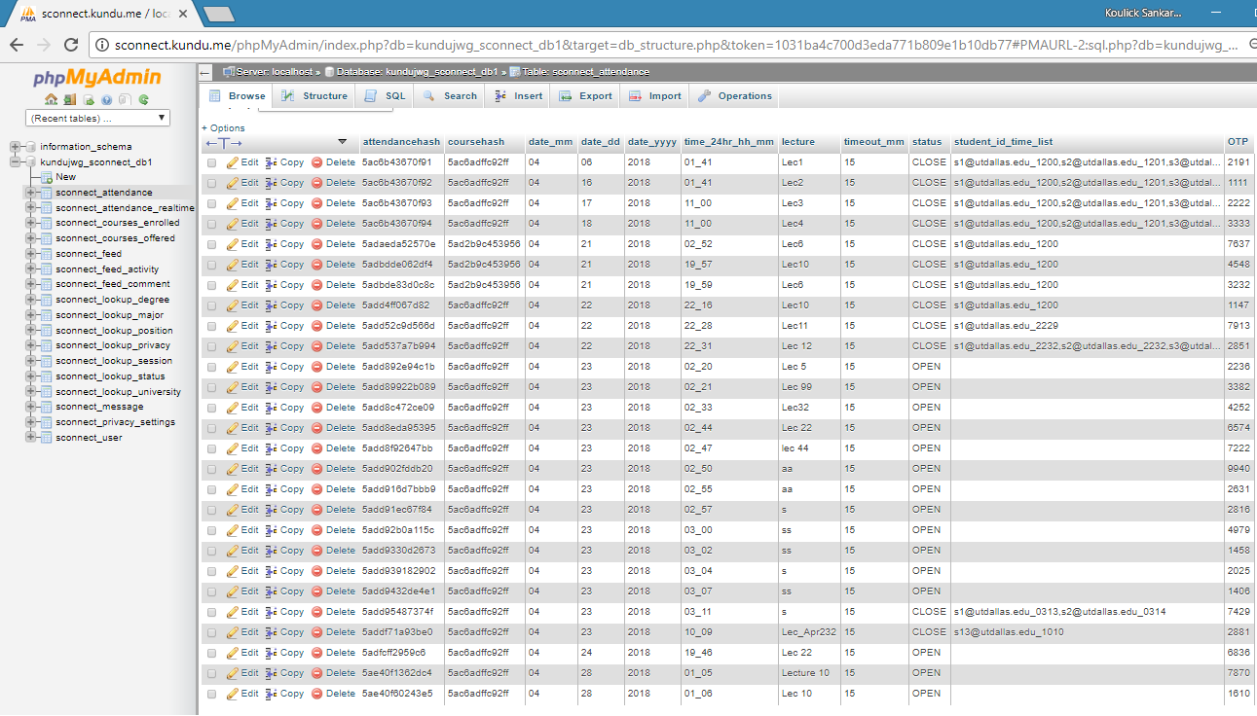

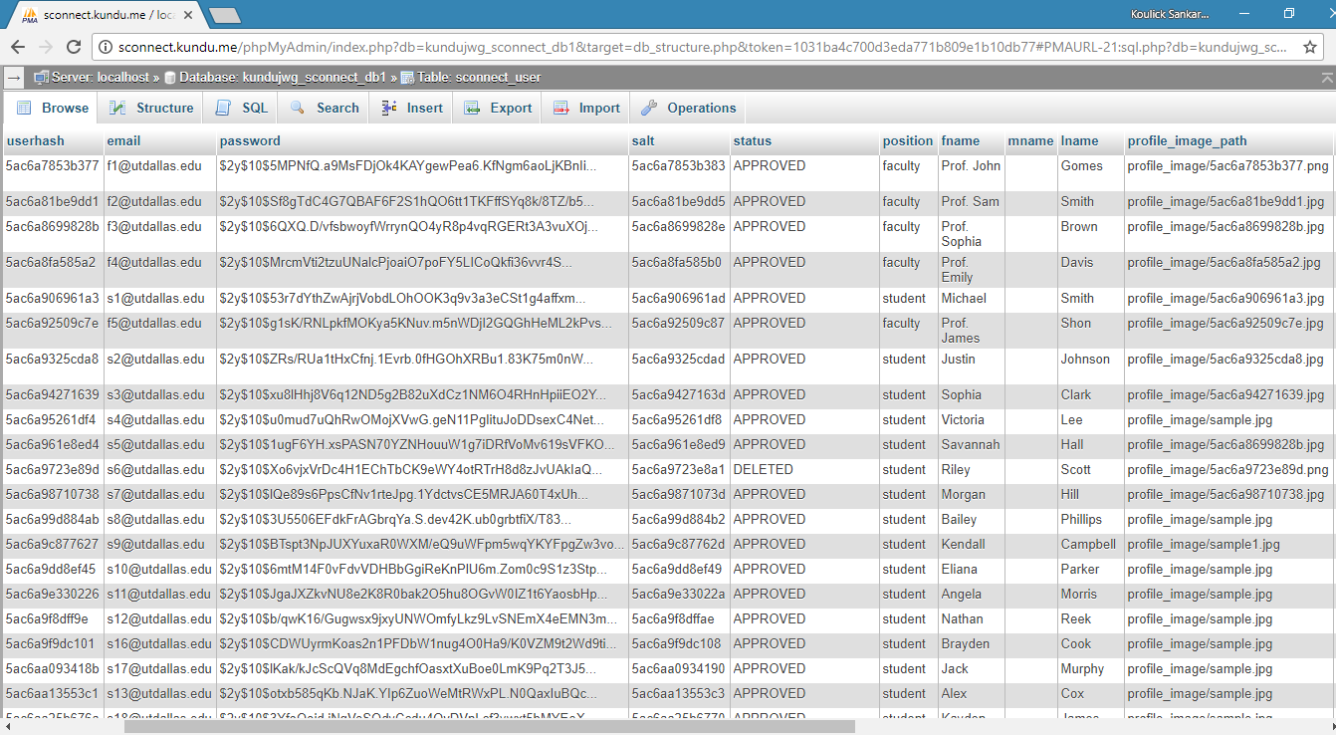

**The create-table sql dump is provided separately along with other artifacts submitted**

**Individual contribution**

This part has been separately provided in an excel sheet posted along with the project artifacts

**Future Scope of improvements**

There are several areas in our project wherein further improvements and more functionalities can be brought about. Currently we have single default-CSS defined for any university profile that logs in, whereas afterwards the profile CSS can be customised and loaded accordingly based on the specific university user that logs into the portal.

We have plans to implement a dedicated chat-box system for our application rather than the current messaging window. Also, further improvements can be done in a way that the currently logged in users would only be shown on the right card of the feed window rather than all users in the system. Currently we have only the OTP generated which needs manual entry into personal email whereas, in future we can link emailing options with this application which would facilitate convenient access to our portal.